**Configuration Guide**

**Network Topology Diagram:**

**Configurations:**

**Wireless Router Configuration:**

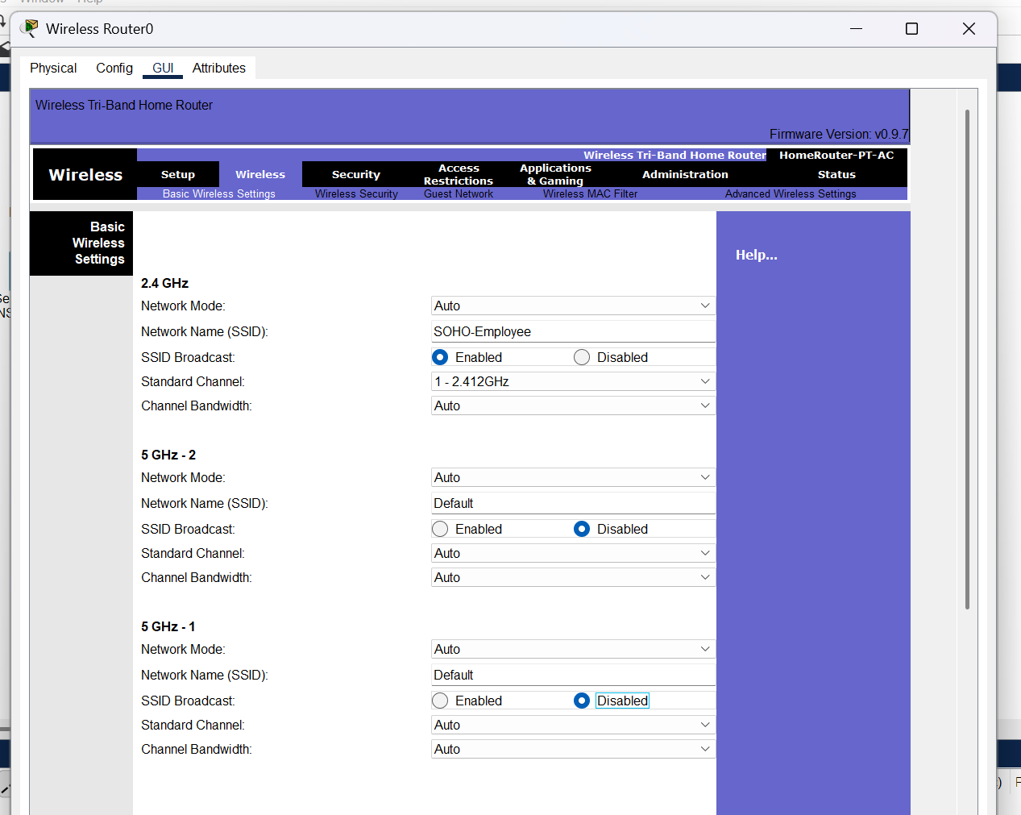

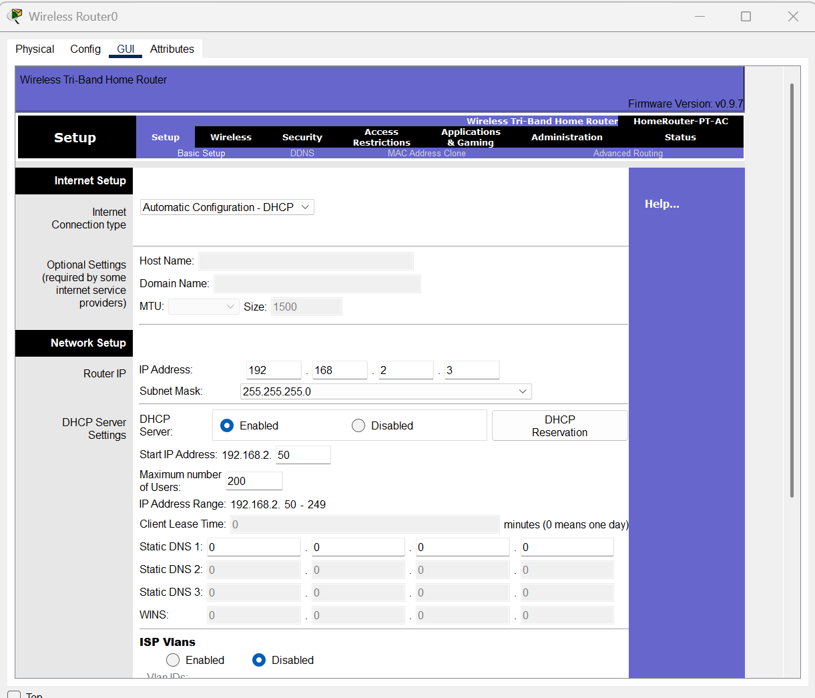

**RADIUS Server Configuration:**

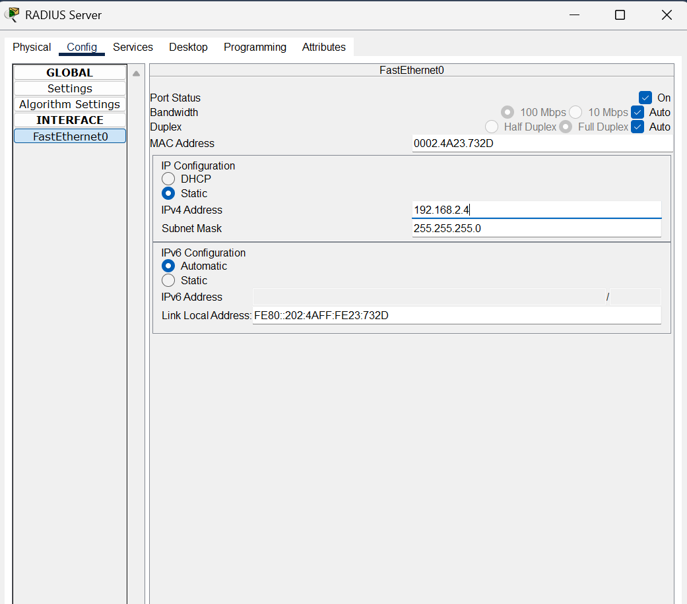

**DHCP Server Configuration:**

**Switch0 Configuration:**

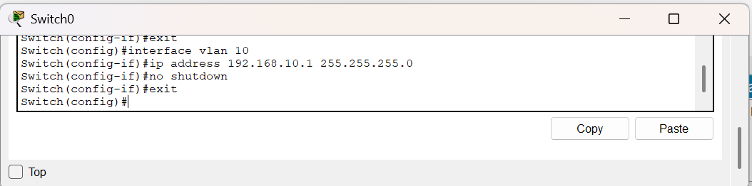

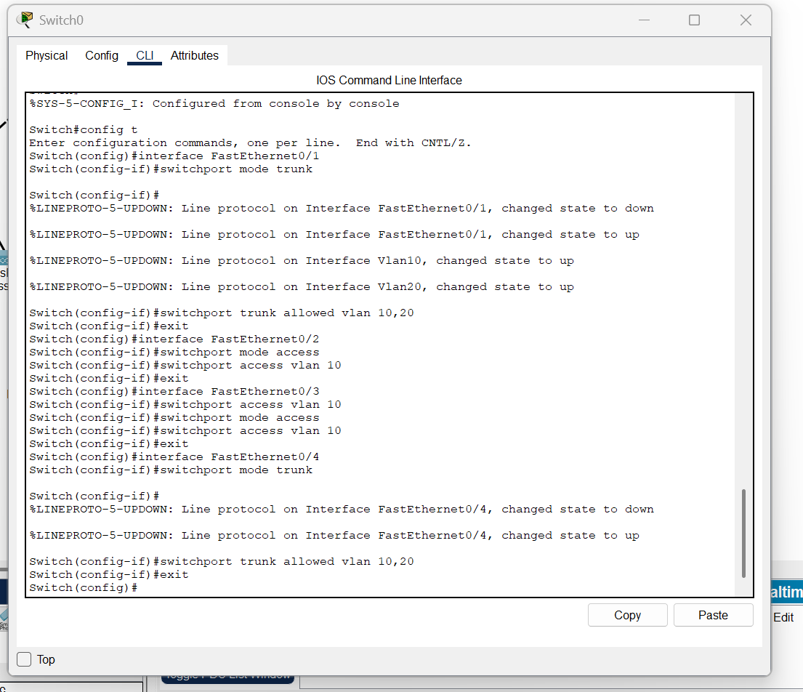

**Router0 Configuration:**

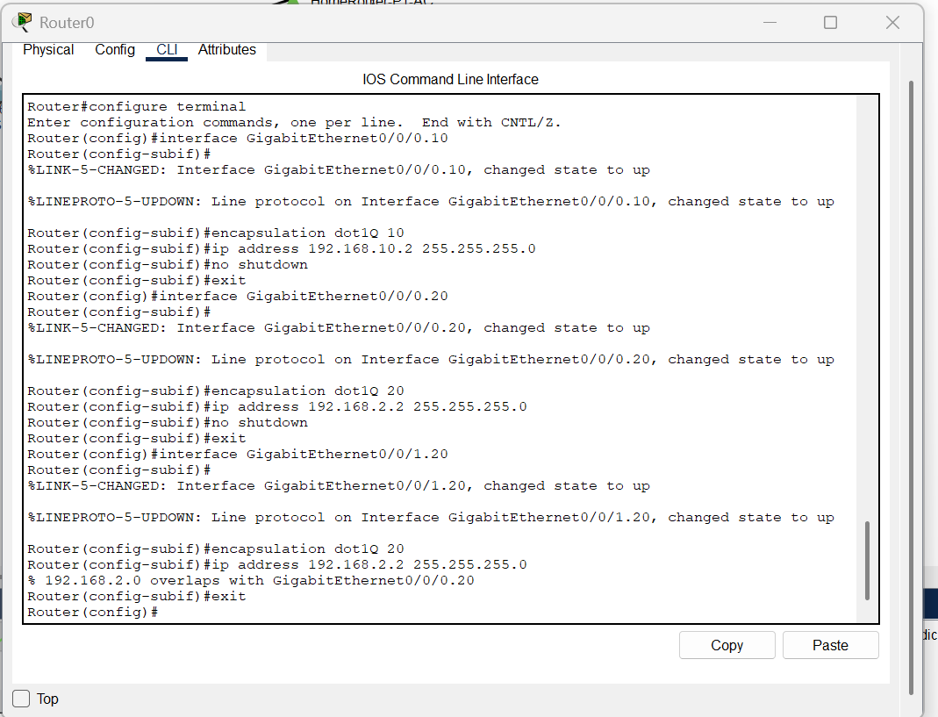

**PC0 Configuration:**

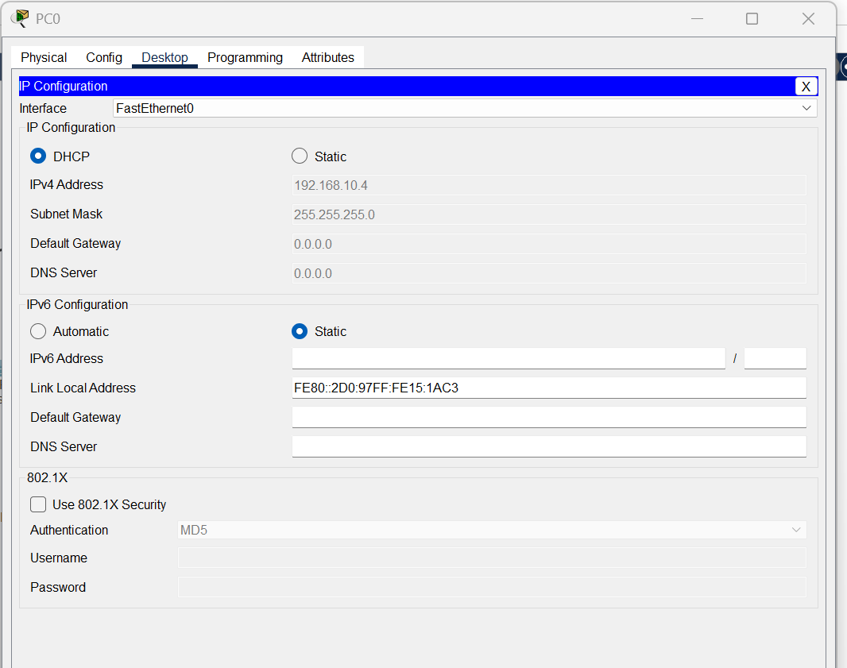

**Laptop0 Configuration:**

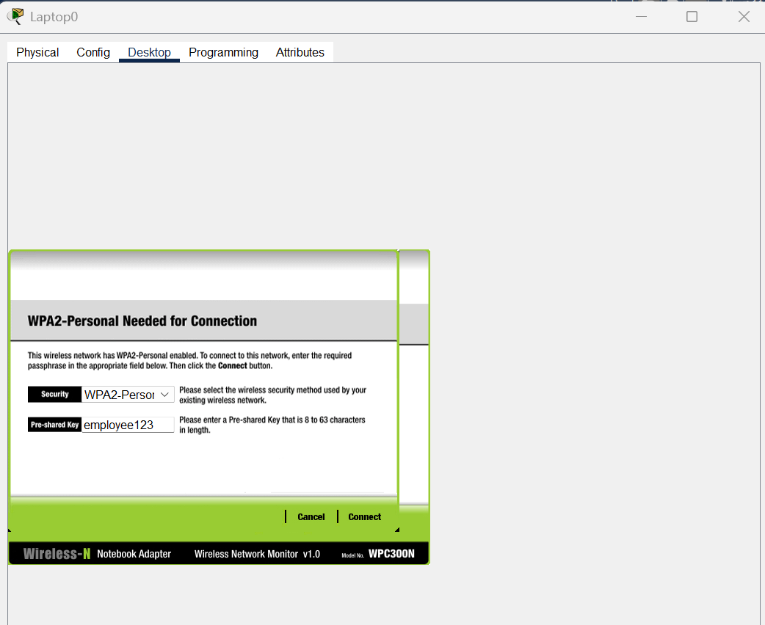

**Switch1 Configuration:**

**Testing and Validation:**



